CSI 113
Windows/E-Mail Lab Assignment

Name | Section Number

This lab will be different than the others. You will do this entire lab without your Microsoft Office 2003 textbook. You may want to print this document and follow the tutorial with a hardcopy. This lab is designed to work with any version of Windows. At the conclusion of this lab, you will have three Word documents to turn in to your instructor, in addition to this coversheet. Your instructor will use this to grade the lab.
Project | Instructor Comments | Points  Possible | Score
Windows Explorer |  | 25
E-mail |  | 25
Deductions:
Assignment late
Other:
TOTAL |  | 50

Please fill in your name and section number above, then copy this page only into another document by selecting the first part of this document above through the end of the table and from the Edit menu select Copy, then paste into a new document (Edit | Paste.) This will be on one page. Save the document as [YourLastName]_windows_gradesheet.doc, i.e. Smith_windows_gradesheet.doc. on your H: drive in the Windows-Email folder you will create in this lab exercise. Please see your instructor if you need assistance.

Part 1: Windows Explorer: Managing Your Files
This tutorial will present "how to" information and practice exercises on file management in Windows. If you have Windows 95/98, instructions are in parenthesis. Otherwise the concepts and procedures are the same for Windows 95/98 and for Windows XP.
**Important: Students often get confused about the difference between Internet Explorer and Windows Explorer. This is probably why in Windows XP they call it "My Computer" or "My Documents" instead. To be clear, Internet Explorer is a Web Browser used to access pages on the Internet and Windows Explorer is a way to manage files on your computer.
Before learning how to Find, Save, Copy, Move, Delete files, etc. lets take a look at one of the most useful tools to help you manage your files. The program is called Windows Explorer. Windows Explorer has been incorporated into My Computer in Windows XP. As you learn about file management in the steps to follow, refer to the image below of Windows Explorer. Notice the identification of the parts of My Computer window below.
If you are reading this online, you may want to print this tutorial to have at your side as you work through it. Or you can go through the practice exercises with 2 windows open – your My Computer window and your browser window. To do this, open both windows. Then at the bottom of the screen right click on the task bar and choose Tile Vertically. Now the 2 windows are side by side for you to follow the directions in the tutorial while you perform the exercises in My Computer.
IMPORTANT NOTE: Throughout this lab exercise you will see this icon:  This icon indicates that you have a task to complete. In each section, the task is explained THEN you perform the task. Do not perform the task until you see the icon.

Accessing My Computer/Windows Explorer
To access My Computer/Windows Explorer:
- Click on Start | My Computer. (In Windows 95/98, click on Start | Programs | Windows Explorer) The Folders icon under the menu toggles on and off and changes the left pane. Click on the folders menu in order to see the drive information in the left pane.
- Size the window for your desired viewing. You can also size each of the vertical windows within the larger one to see all the information. Your screen should look similar to the one below:
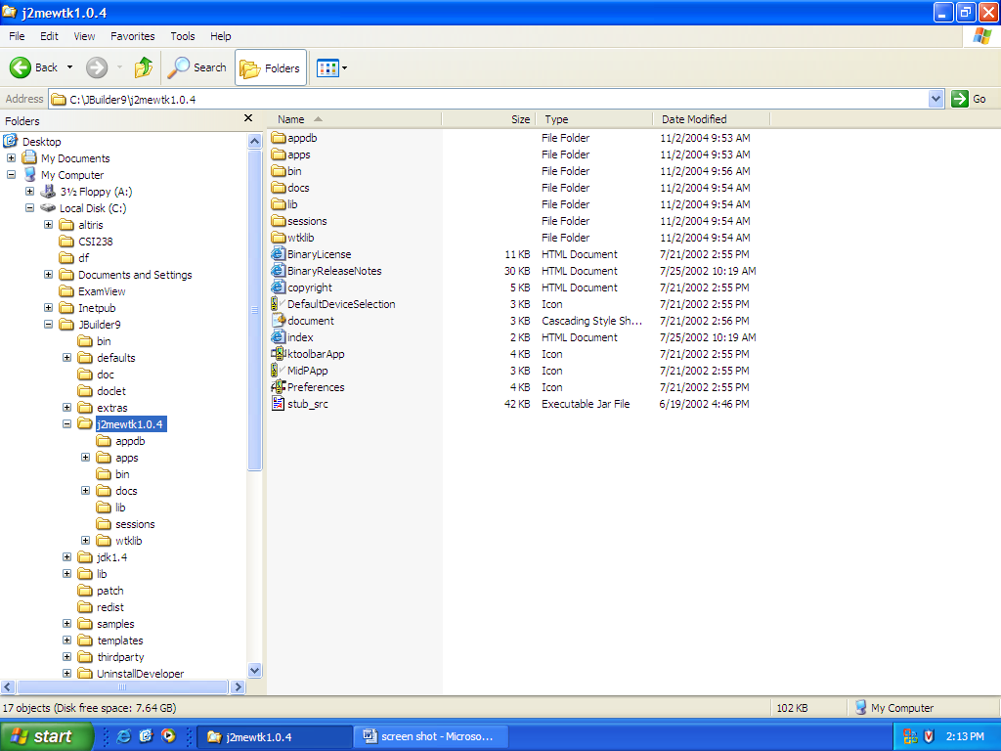
Drives
Subdirectories
Folders/Directories
Files within Folders
Date created or modified
Menu Bar
File Type
File Size
Space free on drive/disk
Status Bar

Parts of Windows Explorer
Try to think of the structure of this file management tool as a filing cabinet with folders inside of filing drawers, etc. This concept is represented in Explorer with a "tree" type of appearance -- directories come off main drives; files come off directories, etc.
On the left side of your My Computer window are the folders in your chosen drive. This view begins with Desktop, followed by My Documents, and then My Computer (Windows 95/98 Desktop | My Computer) and lists all your drives, followed by other folders or programs contained within the Desktop. Notice the directory structure is indicated by the indentation levels in the left pane. On the right side are the files and folders that are contained within the folder you select at left. Your selected folder appears to be open, with its contents spilling out into the right panel.
- A minus (-) sign on a folder means that it is fully expanded.
- A plus (+) sign on a folder means that more folders are contained inside it than are visible.
- If there is a folder with no plus or minus, it means that the folder has no "sub-folders" but there may be files in it.
When you want to see details of your files (i.e. size, date created/modified), click on View | Details. When you just want to see a list of files, click on View | List. In Windows XP, you can also use the Views icon next to the Folders icon to change the view.
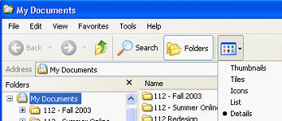
Practice Exercise
Practice moving around in the My Computer window by
- Clicking on the folders on the left side to see how the subfolders and files are displayed on the right side of the window.
- Use the scroll bars in the windows to navigate.
- Click on the items on the menu bar to see the options provided.
- Identify in your My Computer window all the items identified above (i.e. files, folders, scroll bars, menus, etc.)
Formatting a Disk
Before we begin learning about file management in Windows, we will learn about formatting a disk.
- Formatting a disk prepares the disk for reading and writing.
- When you format a disk, the operating system erases all bookkeeping information on the disk, tests the disk to make sure all sectors are reliable, marks bad sectors (that is, those that are scratched), and creates internal address tables that it later uses to locate information.
- A disk must be formatted before you can use it. Most manufacturers pre-format their disks.
- Using a utility in the operating system, you can format a disk.
Practice Exercise - (you may skip this exercise if you do not have a floppy drive, however you will need to know this information)
- Insert a disk in the floppy drive (Note: this process will erase the contents of your disk!)
- Open My Computer (Windows Explorer)
- Right-click on the 3 ½ Floppy A: icon
- Choose Format
- Click OK when format is complete
- Close the format window

How to Create Folder Directories
When you log onto the computers on campus with your unique student ID, you are given access to your home directory (the H: drive.) We will be using this drive in the lab exercise.
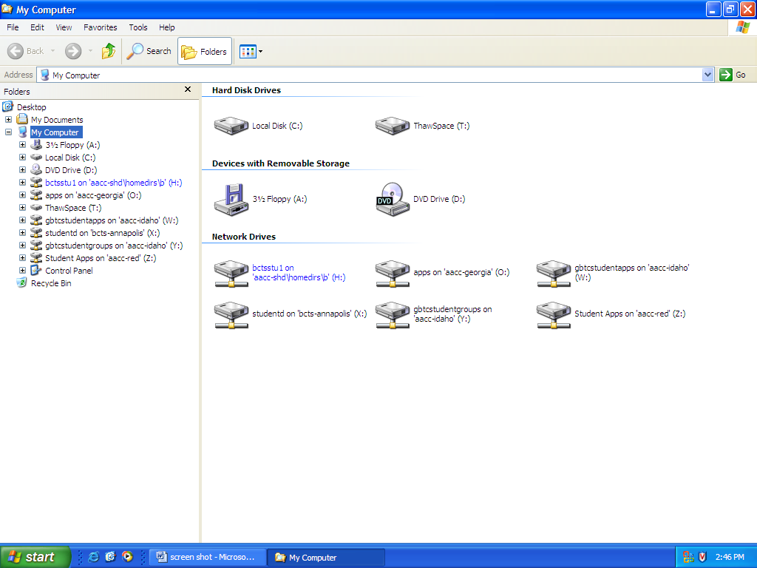
Home directory H: drive
Create folders by performing these steps:
- Open My Computer/Windows Explorer -- Start | My Computer and click the Folders icon (Windows 95/98 Start | Programs | Windows Explorer)
- If your window is small you may need to enlarge it (maximize it or drag the right lower corner).
- To create a folder (directory) on H: click one time on H: (on left pane) to highlight/select it.
- Go up to the menu bar at the top and click on File | New | Folder.
- A folder box appears on the right. Type your desired folder name and click Enter.
- On the menu bar at the top, click View | Refresh and now you will see your new folder on the left. (This is not necessary in Windows XP)
NOTE: Sub folders can be created under already established folders in the same manner. On the menu bar, click one time on the folder and click File | New | Folder
Practice Exercise
In this exercise, you will use your home directory (H:) to create folders. Practice creating folders by doing the following:
- Open Windows Explorer -- Start | Programs | Windows Explorer (XP -- Start | My Computer and click the Folders icon)
- Scroll the left side scroll bar up until you see [H:] and click once on [H:]
- Go up to File on the menu bar and choose New | Folder
- The new folder default name is New Folder so you will need to replace with a new name - CSI 112 Files and hit Enter. (Note: if you are unable to change the file name at this point, simply right-click the folder and select Rename and you will be able to change the name.)
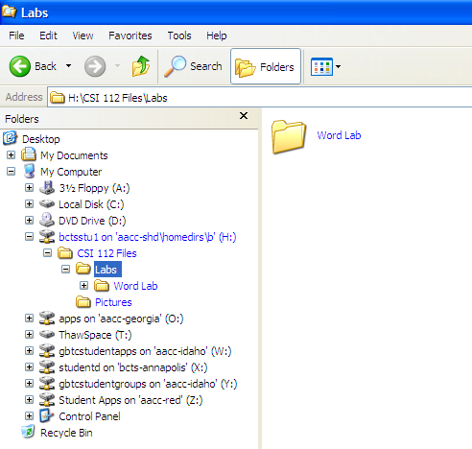
- Now double click the H: drive on the left pane. You should see the CSI 112 Files folder under the H: drive and you should see it in the right pane.
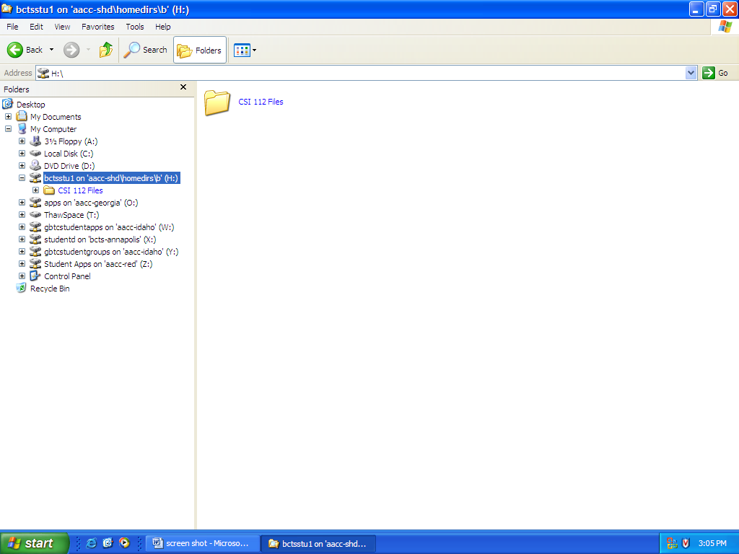
CSI 112 Files Folder

- Click once on the CSI 112 Files folder in the left pane and make another folder called Pictures.
- Go back to the CSI 112 Files folder and create another folder with the name of Labs.
- Click once on the Labs folder on the left pane and create another folder with the name of Word Lab.
- Now create additional folders in the Labs folder for the rest of the labs – Windows-Email Lab, Excel Lab, Access Lab, and PowerPoint Lab.
- The file structure is as follows
H: drive
CSI 112 Files
Labs
Access Lab
Excel Lab
PowerPoint Lab
Windows-Email Lab
Word Lab
Pictures

Saving Files
Although Windows Explorer is not used for saving files, this operation will be covered here, as it involves the need to be familiar with the directory structure of Windows in order to know where to save or retrieve files when using applications.
When saving any document, using any application, you will follow these steps:
- When you are ready to save a file, click on File, Save As
- When the Save As dialog box comes up, click on the drop-down menu at the end of the Save in: box to display your drives.
- Scroll to the drive letter (H: or A: :), then double click on the folder (directory) to which you wish to save the file. You will then see that folder pop into the Save in: box.
- In the File name: box below, enter your choice of a filename.
- In the Save as type: box, you notice that the application being used is already in the box. If you wish to save the file as another file type (i.e. text only, etc.), click the drop-down menu at the end of the box to select.
- Lastly, click on the Save button.
Practice Exercise
In this exercise, you will open Internet Explorer to go on the Internet and download some pictures you will use in your Word lab.
Perform the following steps:
- Open Internet Explorer (this is your Web browser)
- Go to www.google.com. Click on the Images link above the search box.
- Type apartments in the search box and press Enter
- Click on one of the images and click on the link to the full-size image
- Right-click on the image and choose Save Picture As
- In the dialog box, click on the Save in drop-down list and select the H: drive
- Navigate to the Pictures folder you created previously - (H: drive - CSI 112 Labs - Pictures)
- Click Save (save using the default file name.)
- Go back to the Google site and download two more pictures to the Pictures folder
- Note: sometimes there is an error in downloaded these pictures. Simply choose another image to download.
Perform the following steps to save a Word file:
- Open Microsoft Word – Start | All Programs | Microsoft Office | Microsoft Office 2003
- Type: This is a test document.
- Click on File | Save As.
- In the Save in: box, click on the drop down menu and go to (H:).
- Navigate to the Word Lab folder in the CSI 112 files folder
- In the File name: box, type test
- Click on the Save button
- Now close the word processing program and open it up again.
- Click on File | Open, and follow the same procedure as above to locate the file.
- When you locate it, double click on the file to open it into your word processing program.
- You have now completed the exercise and can close your program.
NOTE: When retrieving files with extensions other than the applications extension, you will need to click on All Files in the Files of type: box to see and select your files. For example, WORD automatically puts the file extension .doc after the filename. If, for example, you are using WORD and you saved a file with the name smith.let. When you click on File, Open you will need to select All Files in the Files of type: box to see that file because just the files with the .doc extension will be showing in the file list.

Finding Files
If you save a file and then can't remember what you named it or where it was saved, you can search for the file using the Windows Find feature in Windows 95/98 or the Search feature in Windows XP. Windows allows you to locate files based on file name, a portion of a name, date, and/or the text included in a file.
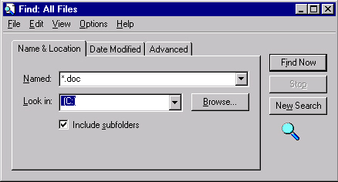
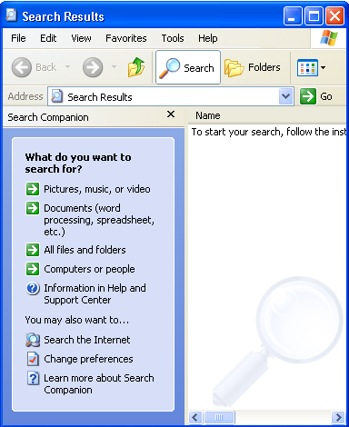
In Windows XP you can click Start | Search or click on the Search icon to the left of the Folders icon in Windows Explorer (My Computer). The Search feature looks like the image below. Windows XP gives more flexibility with your search. You can search for pictures, documents, files/folders, etc.

Windows 95/98

Windows XP

To conduct a search in Windows 95/98, you can
- Use your Start menu and choose Find | Files and Folders, or
- Click on Tools on the menu bar and choose Find | Files and Folders, or
- Right click My Computer, and choose Find.
Using a basic search, you indicate the file name or a portion of the file name (if you don’t know it all) and search either your entire computer, or any drives or directories that you choose.
Here are some examples of ways of searching:
- You saved a Word document to your hard drive [C:] but you can’t remember the name or where it was saved (but would recognize it). The syntax for entering into the Named: box would be
*.doc (this says show all files with a .doc extension*)
*.ppt (this says show all files with a .ppt extension)
- You want to find the file called budg-req. but you only remember part of the name -- budg. The syntax would be
budg* (this says show all files beginning with budg).
- In the Look in: box, click the Browse button and click on [C:] so that the search will start from the main level or root of the c: drive.
- Then click on Find Now to start the search
Your search results screen will list the file or files which match your criteria. The screen functions like a window in Explorer or My Computer. Here you may open, delete, move, and copy files.
*A note about file extensions - a file extension follows a "dot" after the file name. It identifies the type of file and allows a files format to be described as part of its name so that users can quickly understand the type of file it is without having to "open" it. The file name extension also helps an application program recognize whether a file is a type that it can work with. Examples: Word = .doc; Excel = .xls; Access = .mdb, PowerPoint = .ppt; Image files = .jpg, .gif, .tiff; Web files = .html, .htm; Sound files = .mp3, .wav, .midi; Video files = .avi, .mpg. Your operating system may or may not be configured to view file extensions. Follow the instructions below to configure your operating system to view file extensions.
Windows Me, Windows 2000, or Windows XP Users
- In My Computer/Windows Explorer click Tools | Folder Options.
- On the Folder Options window, click the View tab. In the Advanced Settings group uncheck:
[ ] Hide extensions for known file types
- Click Apply | OK. Close My Computer/Windows Explorer.
Windows 95/98 Users
- In Windows Explorer click View | Folder Options.
- On the Folder Options window, click the View tab. In the Advanced Settings group uncheck:
[ ] Hide extensions for known file types
- Click Apply | OK. Close Windows Explorer.
Practice Exercise
Use the above procedure to set up Windows so you are able to view files extensions.
- After performing the procedure, navigate to the Word Lab folder you created on the H: drive. You should see the “doc” extension on the test document.
Practice Exercise
Practice using the search tool by doing the following:
- Open the Search window by clicking Start, Search (Windows 95/98 - Start | Programs | Windows Explorer.)
- Click All files and folders (Windows 95/98 - Open the Find program by clicking on Tools | Find | Files or Folders.)
- In the All or part of the file name box (Windows 95/98 Named: box), type *.doc. This means that you are searching for any file that has a .doc extension. In other words – all Microsoft Word documents.
- Click down arrow, select H (Windows 95/98 – in the Look in: box, click Browse and select H:
- Click on Search. (Windows 95/98 Find Now
You should see all the documents with the .doc extension on your H: drive – in this case it would be the “test” document you created previously. Note: you will only get results if there are Word documents on the H: drive. When you find a file you are searching for, you can double click on the file name and it will launch the application and open your file.

Copying Files
You can use several methods for copying (and moving) files:
- Right clicking,
- Clicking a toolbar icon,
- Clicking edit, copy on the menu bar,
- Pressing control c on your keyboard, or
- Dragging your files to another location. As you gain more experience and confidence, you will probably use the dragging option more frequently. Initially, you may prefer the other options.
Basically when copying files from one directory or drive to another, you are going to select the file, then use one of these methods to copy it to another location.
Practice Exercises
Try the following ways to copy files using the different methods:
RIGHT CLICKING
- Put a disk in your A: drive (or a CD drive if you do not have a floppy drive)
- Open My Computer (Windows 95/98 -- Open Windows Explorer)
- Navigate to the Pictures folder you created on the H: drive. Open the folder so you can see the files on the right
- Right-click one of the apartments pictures you copied into the folder and choose Copy.
- On the left pane, scroll up to the A: drive (or the CD drive) and right-click the drive and choose Paste
- Check it by double clicking on the A: drive (or the CD drive) to see it displayed on the right side
MENU BAR
- Open My Computer (Windows 95/98- open Windows Explorer)
- Navigate to the Pictures folder you created on the H: drive. Open the folder so you can see the files on the right
- Click once on another apartment picture in the Pictures folder on the H: drive, on the menu bar choose Edit | Copy
- Navigate back to the A: drive (or CD drive). Select it by clicking on it once.
- On the menu bar choose Edit | Paste
- Check it by double clicking on the A: drive (or the CD drive) to see it displayed on the right side
KEYBOARD
- Open My Computer (Windows 95/98- open Windows Explorer)
- Navigate to the Pictures folder you created on the H: drive. Open the folder so you can see the files on the right
- Click once on another apartment picture in the Pictures folder on the H: drive press Ctrl C (hold down control while you press the letter c). Then release it--you have just copied it.
- Navigate back to the A: drive (or CD drive). Select it by clicking on it once.
- Press Ctrl V (hold down control while your press v).
- Check it by double clicking on the A: drive (or the CD drive) to see it displayed on the right side
DRAGGING
NOTE: You need both directories visible to use this option. Or you can open up My Computer/Explorer again and move the windows around for good viewing.
- Open My Computer (Windows 95/98- open Windows Explorer)
- Double-click on the A: drive (or the CD drive if that is where you copied your pictures), your pictures should be in the right pane
- Click File | New on the menu to make a new folder. Name the folder Apartment Pictures
- You should see the picture files on the right and the drives on the left
- Select all the apartment pictures by holding down the CTRL button and click on each apartment picture. Release the CTRL button and all three pictures should be selected.
- Place your mouse on one of the files and click the left mouse button as you "drag" the files to the Apartment Pictures folder. Release the mouse and the pictures should move into the folder
- Check to be sure the picture files are in the folder by double-clicking the folder
- Now navigate back to the H: drive and find the Word Lab folder (remember it is in the CSI 112 files folder) and find the test.doc file
- Scroll up to the A: drive (or CD drive) on the left pane
- Left-click the test.doc file and drag it to the A: drive (or the CD drive). Release the mouse
- Now double-click the A: drive to view the contents. You should have a folder named Apartment Pictures (it has 3 picture files) and a file called test.doc
**Notice: when you drag in the same drive, the files are moved (like when you moved the apartment picture files to the folder on the A: drive). When you drag files to a different drive, the files are copied. If you right-drag, it gives you the open to move or copy.

Renaming Files
There are two ways to rename files. Right-clicking and choosing Rename or choosing File | Rename
- Right-click the file (or click the file and choose File from the menu)
- Choose Rename
- Type the new name, including the file extension if you can see the file extension
- BE CAREFUL NOT TO CHANGE THE FILE EXTENSION OR THE FILE WILL NOT OPEN PROPERLY
Practice Exercise
Try renaming a file by doing the following:
- Double click on the Apartment Pictures folder you created on the A: drive to reveal your picture files on the right pane.
- Right click on one of the apartment picture files and choose Rename
- Notice the file extension (i.e. type of file) before proceeding - it is likely that the image is a .jpg or .jpeg file
- Type apartment1.jpg (Warning: be sure not to change the file extension or the file will be unusable. Only use .jpg if that was the original extension) -- Press Enter
- Change the names of the other two apartment pictures as described above. Name them apartment2.jpg and apartment3.jpg
**In order to verify that you have followed the instruction in this tutorial do the following (follow the instructions carefully):
- Open My Computer, select the Folders icon (Windows 95/98 – Open Windows Explorer)
- Expand the H: drive and double click on the CSI 112 Files folder and the Labs folder
- Expand the A: drive by double-clicking. You should have the Apartment Pictures folder and the test.doc file
- On the keyboard press the “Print Screen” key, which on the right of F12 on the keyboard. This keystroke will copy the image of the screen to the electronic clipboard in Windows. Note: this does not activate the printer, it only copies the image to the clipboard.
- Open Microsoft Word - type your first and last name into the document
- Press Enter and type your course and section number (i.e. CSI 112-001)
- Press Enter again.
- Click Edit | Paste from the menu. The image will be copied into the document.
- Click File | Save on the menu and save the document as “[YourName]_windows.doc” on the H: drive in the Windows-Email Lab folder, for example, smith_screenshot.doc
- Leave the file open for the next section.
Your screen shot should look like this:
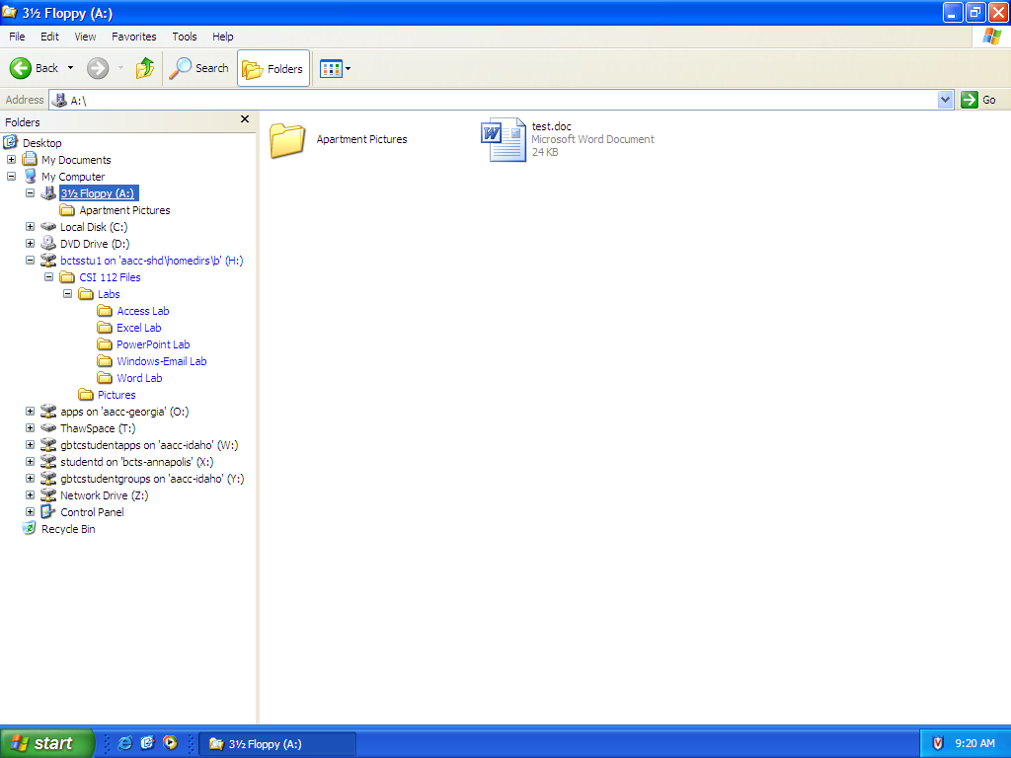

Deleting Files or Folders
Deleting files and folders is easy - almost too easy. Here again, you have several options:
- Select the file or folder and click the delete icon on your toolbar
- Select the file or folder and press the delete key (del)
- Right click the file or folder and choose delete.
- Drag the file and drop it in the recycling bin on your desktop
Unless you have indicated in the recycle bin that you wish all files that you delete to be permanently deleted, and unless you are on a floppy drive, deleting will merely send your files to the recycle bin, from where you can permanently delete them later.
WARNING: When you delete a folder, you delete all files in that folder. Before deleting a folder, be sure that it does not contain files you wish to keep!
Practice Exercise
We are going to try only one of the ways to delete a file. You may try the others on your own.
- Open My Computer/Windows Explorer
- Click on H: drive and navigate to the Word Lab folder you created on the H: drive.
- Right-click on the test.doc file and select Delete and Yes when asked if you are sure
- Remember, that file is not really gone yet. You can retrieve it from the Recycle Bin. But once you empty the Bin, it is history!
**We are going to perform one last screen shot (as described above).
- Open My Computer and click the Folders icon.
- Double-click on the A: drive
- Double click on the Apartment Pictures folder so the images are in the right pane.
- Click View Thumbnails from the menu.
- Make sure that you can see the A: drive expanded on the left and the apartment pictures on the right pane.
- On the keyboard press the “Print Screen” key, which on the right of F12 on the keyboard. This keystroke will copy the image of the screen to the electronic clipboard in Windows. Note: this does not activate the printer, it only copies the image to the clipboard
- Open the “[YourName]_windows.doc document you created previously, if it is not already open. Go to the end of the document and click Enter
- Click Edit | Paste on the menu. Save the document again.
- You should now have two screen shots on the document.
- Reduce the size of the images so that both images are on one page. Make sure that you resize from the corner of the image – see your instructor if you need assistance.
Part 2: Email Using Myaacc

Myaacc Login
Everyone enrolled in this course has an email account through Myaacc. Go to http://myaacc.aacc.edu to login. Most User Names are your first initial, middle initial and last name. If you have a common last name, your User Name may be different. You may check with either your instructor or the Help Desk at 410-777-HELP to verify your username. Your initial password is the first four letters of your last name and the last four numbers of your social security number. Your email address is your login ID@mymail.aacc.edu.

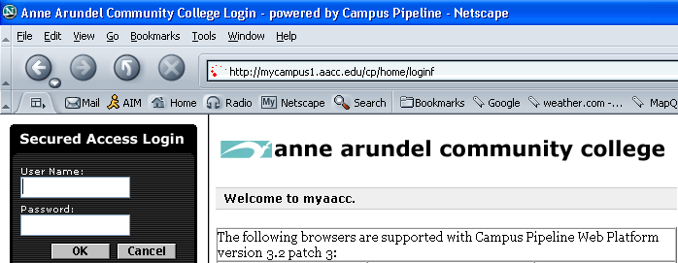
Login here

Starting Email

Once you are logged in, select the email icon.

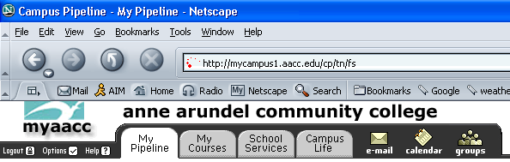
Address Book: Creating Contacts
Notice your e-mail address here

You will now create seven contacts into your address book. Click on the Address Book tab.

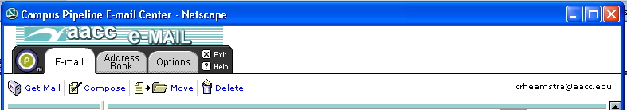

The Address Book gives you options to create a new contact, manage groups (also called distribution lists) or import/export contacts from another e-mail program. Notice how you can navigate through the e-mail section of Myaacc through Your Location.

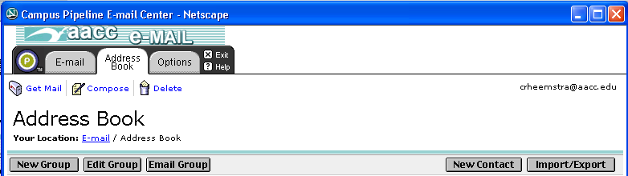
Manage distribution list
Create new contacts
Import/Export Contacts
Navigate through e-mail

Practice Exercise
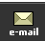
Add names and e-mail addresses of at least 7 contacts (3-4 of them must be other members in the class that you exchange e-mail addresses with) plus your instructor’s e-mail address. Remember , all email addresses are the login ID@mymail.aacc.edu.
- Login to Myaacc and select the icon if you have not done so
- Select the Address Book tab
- Click New Contact
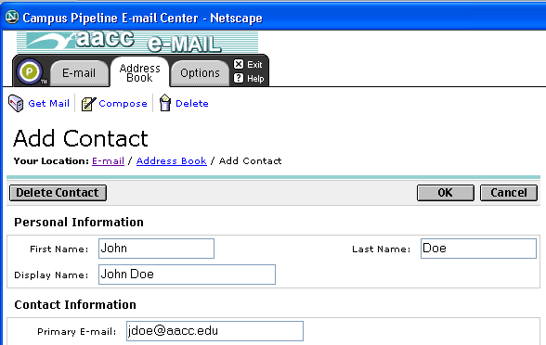

- Enter First Name, Last Name and Primary E-mail only for your first contact.
- Click OK
- Add the remaining names.
- Once all names have been added, click on the Address Book tab (make sure all the contacts are showing.)
- Press Print Screen as you did for the Windows portion of this lab. (See p.10)

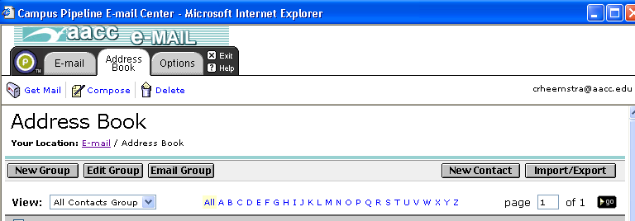
View All Contacts

- Open Microsoft Word.
- Type your name, press Enter
- Type your section number, press Enter
- Click Edit | Paste to past the screen shot.
- Save the document as [YourName]_AddressBook.doc on the H: drive, e.g. Smith_AddressBook.doc

Address Book: Creating a Distribution List

In e-mail applications, a distribution list is a group of mail recipients that is addressed as a single recipient. Distribution lists are used to send e-mail to groups of people without having to enter each recipient's individual address. Myaacc refers to a distribution list as an e-mail group. You are now going to create a “group” for CSI 112.
Practice Exercise
- Click on the Address Book tab in the E-mail section of Myaacc
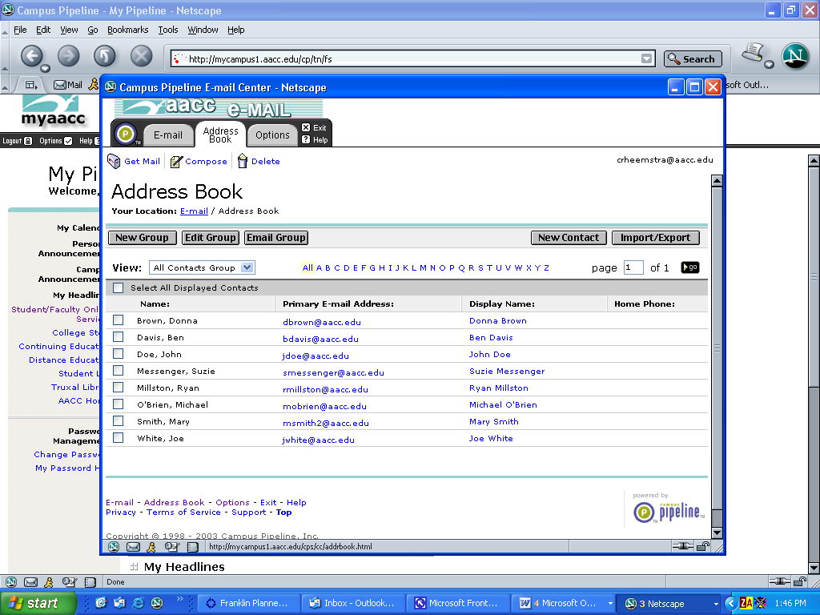
- Select the icon

- Under Group Name type CSI 112.
- Select the individuals that are enrolled in CSI 112 including your instructor, and, using the arrow, add them to the right side

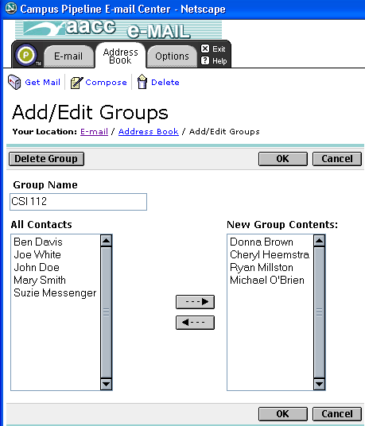
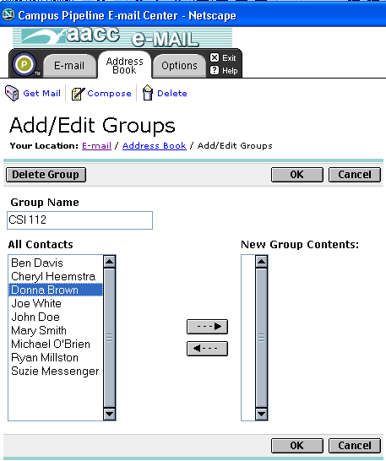
Group Name
Use Arrow to move names to the group.

- Press the Print Screen button to take a picture of the screen. Paste the image into [YourName]_AddressBook.doc you created earlier.
- Reduce the images so they are on one page as you did in the Windows portion of the lab.
- Save the document.
- Go back to myaacc and click OK to save the distribution list/group you created.

Zipping (Compressing) Files
Because of the size of today’s files, it is important to know how to create a compressed file for e-mail. In this section, you are going to learn how to prepare a zipped folder with your lab files. You will then email this attachment to your instructor. There are instructions both for compressing using Windows XP and WinZip, a free compression utility. The WinZip Web site gives a good overview of compressing files: http://www.winzip.com/aboutzip.htm

You will be zipping your screen shot documents and a copy of the first page of this lab assignment as the grading sheet – a total of three documents -
- [Your Name]_windows.doc
- [YourName]_AddressBook.doc
- windows_gradesheet.doc

Practice Exercise

For Windows XP – Windows XP has made it very simple to create a compressed folder. Follow these steps:
- Open My Computer and create a new file folder on the H: drive named YourName Windows, i.e. Smith Windows (File, New, Folder from the menu)
- Move all the files into that folder Right-click on the folder and choose Send To – Compressed (zipped) Folder
- Windows then creates a folder named [YourName]_Windows.zip. This will be the file you attach to the email you send to your instructor.

For those without Windows XP – WinZip – If you do not have Windows XP You can download a free trial version of the compression utility called WinZip at http://www.winzip.com.
- Open WinZip in the WinZip Wizard mode. (If the WinZip Wizard does not open by default, just click the Wizard button in the toolbar.)
- You will be asked "What do you want to do?" Simply select "Create a new Zip file" and click Next.
- The WinZip Wizard will guide you through the entire process.
- Upload the zipped file through your email in WebCT.

Composing and Sending Email
You are now going to send an email to your CSI 112 group.
Practice Exercise
- Open your e-mail account in Myaacc
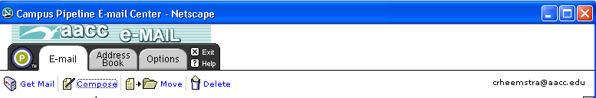
- Click on Compose

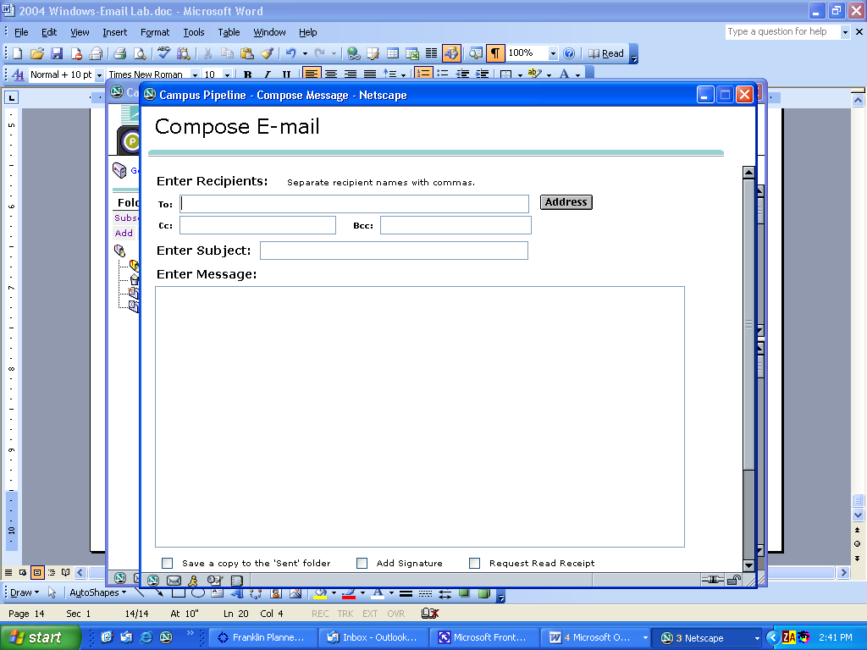
- Then Click on button
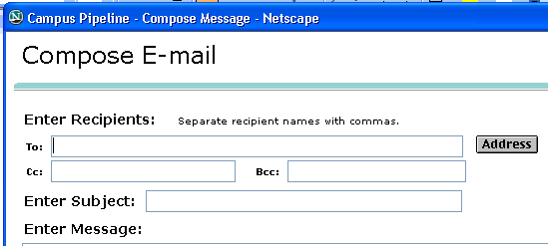

- Select CSI 112 under Groups and click the 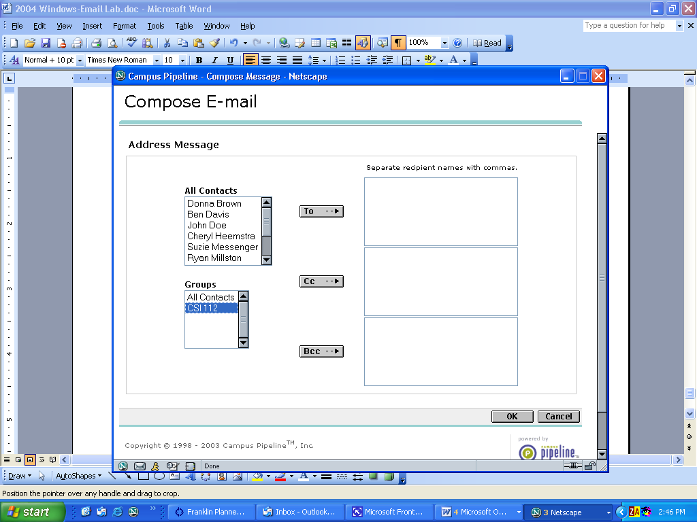 button
- Click OK

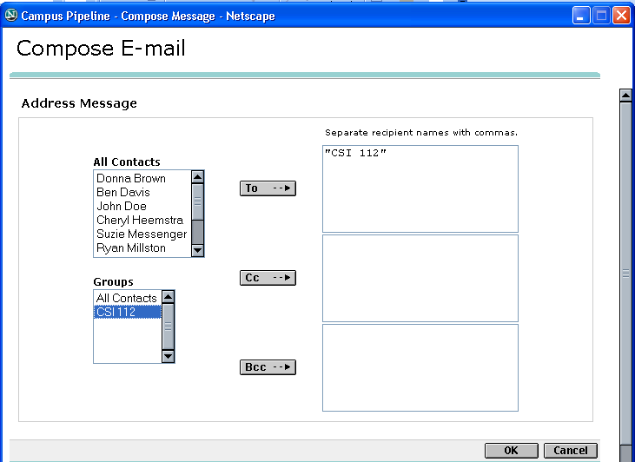
Click OK

- In the Subject section, type [YourSection#] [YourLastName] – Introduction
(eg.. 012 Smith – Introduction)
- In the body of the email, you will introduce yourself using a minimum of 250 words. Use the following list to help you get started Do not feel compelled to provide personal information if you are not comfortable
  - Describe your educational background and work experience. Include your course load this semester, your current employment status and how many hours per week you work.
  - Describe your feeling about technology in general and your experience with it.
  - What experience do you have with the Microsoft Office suite - e.g. Word, Excel, Access, and PowerPoint?
  - Why are you taking this course? What do you hope to get out of it?
  - Describe about your computer. (e.g. brand, age, processor speed, size of RAM and the hard drive, software you use, type of Internet connection - high-speed or dial-up)
  - Describe something about yourself that is not related to computers such as your family, hobbies, what you like to do for fun, something you think others would find interesting, or something currently going on in your life.
- Click Send
Replying to an E-mail
After you send your email, your instructor will reply to your email and request that you send your zipped files for your lab assignment. You will reply to this email and attach the zipped files to your reply.

Practice Exercise
- When you have completed your lab assignment and have received your instructor’s e-mail, Click Reply.
- Change the Subject line to [YourSection] [YourLastName] – Windows/Email Lab
eg.: 012 Smith – Windows/Email Lab.
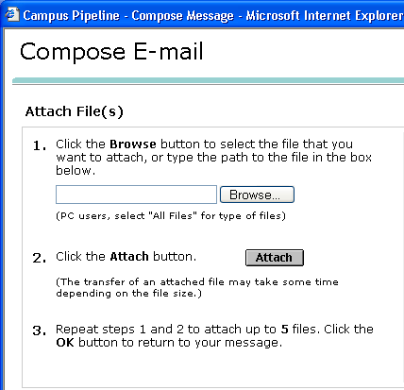
- Scroll to the bottom and click Attach.
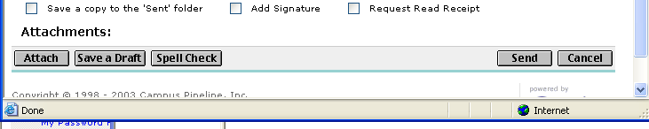
- Click Browse

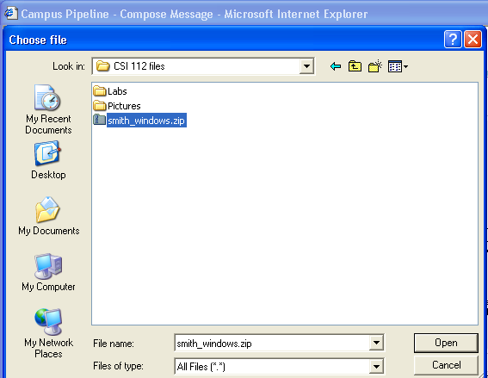

- Navigate to the zipped file and click Open

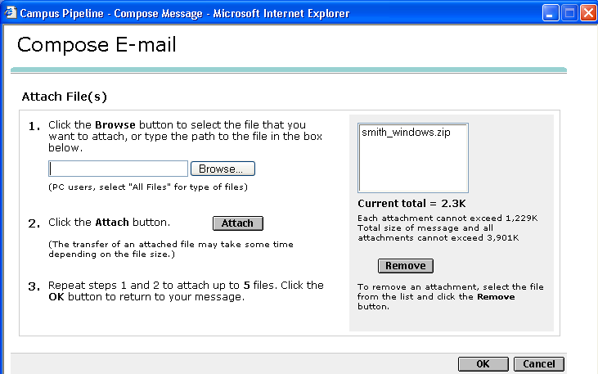
- Click Attach, then OK

- You should see the attachment at the bottom of the email.
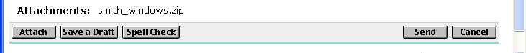

- Click Send

