Pizza HTML Page Assign
You are to create a web page that will allow customers to buy the pizza of their choice online. To achieve this goal you will use the Windows "Notepad" application.
Launch "Notepad" by selecting "Start", "All Programs", "Accessories", and "Notepad."
Create a folder on your floppy drive by selecting "file", "save as", then click on the "new folder" icon (see figure below). Name the folder “My Pizza Web.”
Save your HTML document into the new folder, it is essential that you name the document: “pizza.html.”
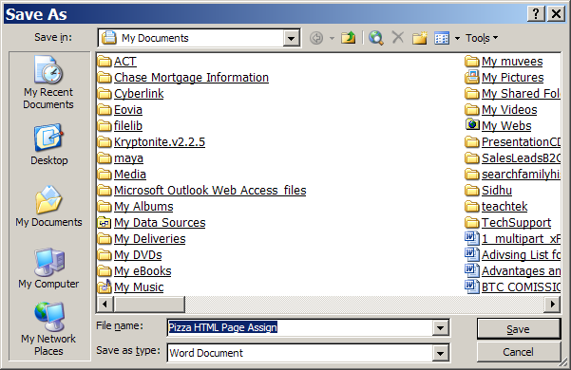

Add an image of a juicy, tasty looking, pizza to your newly created “My Pizza Web” folder, name the image “pizza.gif.” There are images on the “X drive” in the CSI 113 folder). If the image you are choosing is a JPEG (in order to find out right click on the image and select properties), then save your image as pizza.jpg.
Key the following code in your Notepad application:
<HTML>
<HEAD>
<TITLE>OnlinePizza.Com Order Form</TITLE>
<SCRIPT TYPE="text/javascript">
<! --
function validate(myForm) {
var rbchecked = 0;
for (i=0; i<myForm.type.length; i++) {
if (myForm.type[i].checked) {
rbchecked = 1;
}
}
if (!rbchecked) {
alert("Please choose a size for your pizza.");
return false;
}
else {
return true;
}
}
//-->
</SCRIPT>
</HEAD>
<BODY BGCOLOR="lightblue">
<center><img src="pizza2.gif"></center>
<A href="pizzaweb.jpg"><H1>OnlinePizza.Com</H1></a href><p>
<left align>My Pizza.com offers services to pizzeria lovers that are geared directly towards your taste buds. From the East coast to the West coast, here you will find great tasting pizza to light up your desire for good flavor. Check it out!</left align>

Order your pizza with our handy-dandy form below:<P>
<FORM ACTION="orderprocess.p1" METHOD="POST" onsubmit="return validate(this)">
<TABLE BORDER=0 CELLPADDING=8>
<TR VALIGN="TOP">
<TD><B>Type:</B></TD>
<TD>
<INPUT TYPE="RADIO" NAME="type" VALUE="10"> 10 inch round
<INPUT TYPE="RADIO" NAME="type" VALUE="12"> 12 inch round
<INPUT TYPE="RADIO" NAME="type" VALUE="16"> 16 inch round
</TD>
</TR>
<TR VALIGN="TOP">
<TD><B>Toppings:</B></TD>
<TD>
<SELECT NAME="toppings" SIZE=5 MULTIPLE>
<OPTION>Mushrooms
<OPTION>Peppers
<OPTION>Onions
<OPTION>Pepperoni
<OPTION>Extra Cheese
</SELECT>
</TD>
</TR>
<TR><TD COLSPAN=2><INPUT TYPE="SUBMIT" VALUE="Order It!"></TD></TR>
</FORM>
</TABLE>
</BODY>
</HTML>

Save your document in the “My Pizza Web” folder as “pizza.html”

When you finish open your site using either “Internet Explorer” or “Netscape.” Your site should look like the one shown in the figure below.

